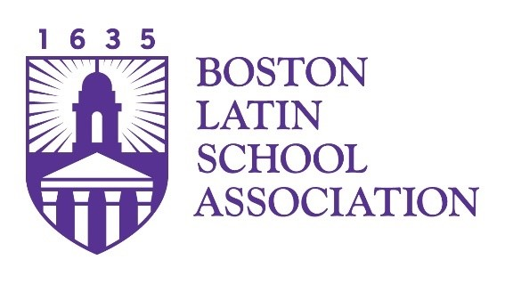
Position Announcement:
Communications Specialist

The Boston Latin School Association (BLSA) seeks a new member for its fundraising and constituent engagement team that will accelerate our communications capacities and allow us to better reach our community of potential benefactors with the good news of successes among the students, faculty, and alumni of Boston Latin School (BLS).
Collaborating with colleagues and outside vendors and partners (e.g., writers, designers, printers, etc.), the Communications Specialist will assume wide-ranging responsibility for all manner of print and digital communications including, but not limited, to:
- the shared BLS – BLSA website;
- an annual print magazine/newsletter;
- periodic e-newsletters;
- social media channels; and,
- community-wide e-mails and appeal letters.
Producing content and determining schedule and strategy are important responsibilities as is responding to occasional media inquiries and maintaining historical records and photo libraries.
This position, like all others on the staff, will also have customer-facing service responsibilities as well as administrative support functions that ensure our small team flexibly meets peak seasonal demands around activities such as reunion, board meetings, and other large-scale events. Work with board committees will give the individual a broad touch on the organization beyond the communications function.

Preferred Qualifications and/or Experiences:
The position requires prior communications experience in a professional setting, with particular strength in verbal and written communication skills. In addition, the BLSA seeks an individual with the following qualities:
- facility in digital and social media channels;
- understanding of HTML, website design, and website optimization;
- editing, proofreading, and design experience with firm understanding of AP Style;
- proficiency in Microsoft, Adobe, and Google office productivity and design/presentation tools as well as knowledge of/facility with Photoshop, Canva, and similar packages;
- knowledge of urban public education generally and Boston Latin School in particular.

Position Details:
Title: Communications Specialist
Reports to: President
Salary: Commensurate with experience; generous benefits package plus professional development opportunities
Setting and Hours: Hybrid (60% in office after initial 100% in office training). Full-time standard business hours with the expectation of occasional evening and weekend work for events.

About the Boston Latin School Association
An independent 501c(3) non-profit foundation, the BLSA builds community among alumni and families of current students and connects them through philanthropy to the nation’s oldest public school, Boston Latin School. The BLSA engages in a wide range of community building activities. It also raises funds and manages a sizeable endowment that together allow the BLSA to invest approximately $4 million annually in the faculty and students of BLS. A small staff of nine professionals works with a board of trustees comprising alumni and parents of current students that reflects the broad diversity of the school and our alumni constituency. The organization also involves more than one hundred other volunteers in our work while executing events that welcome more than 1,500 guests annually.
The BLSA lives its values as an organization committed to diversity in every regard. Our staff is multi-racial/ethnic, multi-lingual, multi-generational and gender diverse. Recognizing that no candidate is ever a perfect match with all preferred qualifications, we encourage applications from an array of individuals who have related experiences. We also highly value connection to Boston Latin School and strongly encourage alumni to apply.

How to apply
Please send resume and cover letter to:
By USPS to:
Felipe Flores Herrera, Vice President of Finance and Administration
Boston Latin School Association
300 Fenway, Ste. A375
Boston, MA 02115

By email to:
blsa@blsa.org

